**Target Journal**

Frontiers in Plant Sciences or G3

**Title**

Using RNA-seq in a genetic mapping population for placement of genomic scaffolds, fixing misassembles, and creating a genetic map in a well utilized mapping population of *Brassica rapa*.

**Authors**

Markelz RJC, Covington MF, Brock M, Devisetty UK, Kliebenstein D, Weinig C, Maloof JN

*Brassica rapa* is an emerging model species for agronomic, ecological, evolutionary and translational studies. Here we describe high-density SNP discovery and genetic map construction for a *Brassica rapa* recombinant inbred line population. We also use the genotype data from the population to detect and remedy putative genome mis-assemblies and to assign scaffold sequences to their likely genomic locations. These improvements to the assembly represent 7.1-8.0% of the annotated *Brassica rapa* genome. We demonstrate how this new resource is a significant improvement for QTL analysis over the current low-density genetic map by increasing mapping resolution and providing genomic coordinates of the molecular markers to aid in candidate gene discovery. These improvements in the genome annotation and new molecular resources should be of general interest to the Brassicacaea genomics community.

**Introduction**

The Brassica genus provides up to 12% of oil calories and is important for providing micronutrients in human diets throughout Asia (Wang *et al.* 2011), book ref, fao/stat/website). Recently sequenced species within this genus include *Brassica napus*, *Brassica rapa*, and *Brassica oleracea* (Wang *et al.* 2011; Liu *et al.* 2014; Chalhoub *et al.* 2014). *Brassica rapa* is a physiologically and morphologically diverse diploid species has 87% gene exon similarity to the model plant *Arabidopsis thaliana* (Cheng et al. 2013). This makes *Brassica rapa* a great candidate for comparing and translating knowledge of biological processes into a crop species from Arabidopsis. For example, using homologous Arabidopsis gene information to infer the action of B. rapa genes in flowering time (Lou *et al.* 2011; Xiao *et al.* 2013), leaf development (Baker *et al.* 2015), seed yield and oil content (Brock *et al.* 2010; Dechaine *et al.* 2014). All of these important traits contribute to our understanding of plant growth in agricultural settings and are made possible by a reference genome sequence (Wang *et al.* 2011) and gene annotation information (Cheng *et al.* 2013; Devisetty *et al.* 2014).

*Brassica rapa* has a genome size of 283.4 Gb spread over 10 chromosomes A01-A10 (Wang et al. 2011). Although the current genome is diploid, there are three ancient subgenomes called Least Fractionated (LF), most fractionated one (MF1), and most fractionated two (MF2). These three subgenomes share many homologous genes and contiguous regions adding the difficulty in assembling chromosomes in the correct order. For example, there are still many gene containing genomic scaffolds in version 1.5 of the genome (http://brassicadb.org/brad/index.php) that have not been placed on a chromosome due to lack of information as to where they belong. These scaffolds equate to ~X% of the remaining sequence left to be placed in the genome.

An increasingly common way to place scaffolds is to use molecular marker recombination information between scaffolds and flanking genomic sequence (Hahn *et al.* 2014). In fact, this approach was used for the original *Brassica rapa* genome assembly, but there were still missing molecular markers on the unplaced scaffolds. The most time consuming part of this step is making a genetic mapping population and sequencing the progeny for genotype information (Cheema and Dicks 2009; Hahn *et al.* 2014; Fierst 2015). There is also no guarantee that there will be recombination events and molecular markers around the scaffolds in the mapping population (Fierst 2015).

For this study we leveraged an existing recombinant inbred line population of *Brassica rapa* (BraIIRRI, (Iniguez-Luy *et al.* 2009)). This population has been used extensively for QTL mapping of physiological, developmental, and evolutionarily important traits (Dechaine *et al.* 2007, 2014; Brock *et al.* 2010; Lou *et al.* 2011, 2012; Baker *et al.* 2015). Recently, we completed deep RNA-sequencing of the parents of the Bra-IRRI population providing a large SNP set and improved gene annotation information (Devisetty et al. 2014). We now extend these methods to 124 genotypes in the population for SNP discovery, the creation of a saturated genetic map, and fixing genome misassemblies and placing scaffolds.

**Methods**

**Plant Growth and Tissue Collection**

The field site was located at the University of Wyoming Agricultural Experimental Station in Laramie, Wyoming, USA. This study focused on 125 recombinant inbred lines and the two parental genotypes of the *Brassica rapa* IRRI population . Individual plants were sown on XXX potting media on XXXX date in a greenhouse and transplanted to the field on XXXX date following established protocols (Dechaine et al. 2014). Each biological replicate of each genotype filled one of five blocks. After plants were established in the field three weeks, apical meristem tissue was collected from individual replicate plants into 1.5 mL eppendorf tubes and immediately flash frozen in liquid N and stored at -80C until RNA-isolation.

RNA-seq library preparation and sequencing

RNA-Seq libraries were prepared using high-throughput Illumina RNA-Seq library extraction protocol (Kumar et al. 2012). The enriched libraries were then quantified on an Analyst Plate Reader (LJL Biosystems) using SYBR Green I reagent (Invitrogen). Once the concentration of libraries was determined, a single pool of all the RNA-Seq libraries with in each block was made and then run on Bioanalyzer (Agilent, SantaClara) to determine the product size of the final pool. Finally each pool is adjusted to a final concentration of 20 nM and sequenced on 7 lanes on Illumina Hi-Seq 2000 flowcell as 50-bp single end reads. All the failed samples from all 5 blocks were run on 2 additional lanes.

**RNA-Seq Read Processing**

Pre-processing and mapping of Illumina RNA-Seq raw reads was done as described in detail in (Devisetty et al. 2014) with one exception. The raw reads were quality filtered with fastq_quality_filter with parameters [-q 20, -p 95]. The qualified de-multiplexed reads were then mapped to B. rapa reference genome (Chiifu version 1.5) using BWA v0.6.1-r104 (Li and Durbin, 2009) with parameters [bwa_n 0.04] and the unmapped reads are in turn mapped with TopHat with parameters [splice-mismatches 1, max-multihits 1, segment-length 22, butterfly-search, max-intron-length 5000, library-type fr-unstranded].

**Genotyping**

Individuals in the population were genotyped first using the reference set of coding SNPs (cSNPs) that were called as part of our established pipeline (Devisetty et al. 2014) . However, once merging all the outputs for the RILs there were inconsistencies suggesting that the parents of the population had more then one parent. The R500 SNPs were consistent across all the individuals whereas the IMB211 SNPs were not suggesting that the parental seed stock has cross pollination contamination. There was not any evidence that the R500 seed stock was contaminated. This led us to approach this using an alternative genotyping strategy by combining all the individual replicates per RIL into a single file to call SNPs compared to the reference genome. Each SNP was filtered by first comparing it to the genotype of the R500 parent. At each SNP, each RIL was genotyped as R500 or the alternate allele. All these SNPs needed to match up with the one another across the population as an extra precaution. At each step there were quality scores and filters that were applied using custom Perl scripts (“mfcovington/SNPtools”). Only SNPs that met our quality scores were considered.

**Genotypic Bin Creation**

All of the SNPs were then assembled along the chromosomes according to their genomic location. Aligning all the individuals in the population allowed us to calculate unique recombination events present in the population. These unique bins were determined by custom Perl scripts (“mfcovington/detect-boundaries”).

**Fixing Misassembled Genomic regions**

Many of the genotypic bins contained more than one SNP. SNPs located in the middle of the genotypic bin were selected for placement of scaffolds and the creation of the genetic map. Asymmetric binary distance was calculated between each SNP to provide a genome with view of the correlation between bins adjacent to one another based on version 1.5 of the *Brassica rapa* genome.

Genetic Map Construction

Using one unique SNP per genotype bin, we created a saturated genetic map. The genetic map was constructed using the chromosomal position of each of the SNPs as a starting point for marker ordering along the chromosomes. Each chromosome was treated as a large linkage group and each SNP was tested for linkage disequilibrium with all other SNPs with the R/QTL package (Broman et al. 2003) in the R statistical environment (R-ref). Larger gaps in RNA-seq information corresponding to low gene density centromeric regions were problematic when ordering markers using the ripple() R/QTL function. In chromosomes A08 and A09, after local marker order was established we used the physical position of the SNPs to connect the two arms in the correct orientation. The orientation of the scaffolds cannot be determined with the current methods because we are limited by the size of the population. Therefore, scaffolds were placed between adjacent bins determined by lowest recombination probabilities. Spline regressions were fit to the physical versus genetic distance for each chromosome using the final version of the map using the loess() and predict() functions in R.

**QTL Comparisons**

To demonstrate an improvement in coverage in mapping physiological traits, we remapped two traits from (Brock et al. 2010) that used the existing genetic map. As the fairest comparisons between maps, marker regression was performed using the scanone() function in R/QTL with 10,000 permutations to determine the significance cutoff.

**Results and Discussion**

R500 vs. IMB211 polymorphism identification

We performed deep RNA sequencing of 124 members of a recombinant inbred line (RIL) population derived from a cross between the *Brassica rapa* accessions R500 and IMB211. We sequenced each member of the RIL population with 5 replicates at an average of X reads mapped per replicate for a combined mean of X reads mapped per RIL. To identify polymorphisms within the RIL population, we first looked for SNPs and INDELs between R500 and IMB211, the parents of the population. We used an approach previously described for the identification of polymorphisms between R500 and IMB211 with an earlier version of the *Brassica rapa* genome annotation, v1.2 (Devisetty et al. 2014). In the current study, we used v1.5 of the genome for all mapping and informatics work. This set of R500 vs. IMB211 polymorphisms was used to genotype each member of the RIL population. Based on the crossing scheme used to create the RIL population, we would expect homozygous regions of contiguous R500 alleles alternating with homozygous regions of contiguous IMB211 alleles. When using this polymorphism set to genotype the RILs; however, there were several regions where R500 and IMB211 alleles were interspersed with no apparent pattern. This suggests that a different parental source may have been used to construct this RIL population.

To test this hypothesis, we merged all of the sequence data from the individual RILs and then genotyped the merged dataset (Figure 1A). Given the relatively large size of the population and the expected introgression frequency and distribution, polymorphisms generated by comparing the actual parents of the RIL population should be segregating with approximately equal allelic frequency in this merged data set (black dots in Figure 1A). Most polymorphisms did display this expected distribution; however, there were several large regions that were not segregating, instead they were monomorphic for one of the putative parents of the population (indicated as orange or blue dots in Figure 1A). Nearly all of these regions matched the putative R500 alleles. The primary exception is the bottom of chromosome A03, which displays a gradual transition from equal R500:IMB211 allelic frequency to nearly all IMB211. This pattern is consistent with segregation distortion within the population possibly caused by the centromere being located that the end of chromosome A03 (Cheng et al. 2013).

One explanation for the other non-segregating regions is that the seed stock of one or both of our parental lines was not actually the true parent of the population. To evaluate this possibility, we sequenced several additional seed stocks of R500 and IMB211. The genotypes of all X R500 seed stocks were consistent with one another across all polymorphisms. There were, however, at least X distinct genotypic variants within the X IMB211 seed stocks. Therefore, we proceeded to work under the assumption that the sequences from the R500 seed stocks that we have provide a reasonably accurate genotypic representation of the R500 parent used to create the R500-IMB211 RIL population initially.

**Population-based SNP discovery**

Due to the uncertainty surrounding the IMB211 parent of the RILs, we switched to a population-based approach for discovering SNPs. This new strategy involves identifying variants within the RIL population and using the R500 data to determine which is the R500 allele and which is the IMB211 allele for each SNP. Using this approach, we identified 146,027 SNPs across *B. rapa*'s ten chromosomes (Table 1).

Using the population-based SNPs to genotype the merged RIL sequence data produces the expected allele frequencies throughout the entire genome indicated by black dots across all chromosomal segments except the end of A03 (Figure 1B). Over X% of the genome is within X bp of a SNP; however, there are several regions with few or no SNPs. There are two primary reasons for these SNP-free regions. Most are likely gene-poor regions or regions of genes with insufficient expression under our experimental conditions (e.g., growth conditions, age, tissue, genotypes). We also found a few regions where there are significant numbers of expressed genes, but no SNPs between members of the RIL population. (These regions primarily correspond to the homozygous regions of Figure 1A and, therefore, likely represent regions that are very similar between the seed stocks used to generate this RIL population.

**Genotyping the RIL population**

Each RIL was genotyped according to the R500 or alternate allele (IMB211 in the figures).

Using the sequencing information on the entire population instead of just the parents provides many more observations of the potential SNPs in the population. For example, an equal segregation ratio for an individual SNP would provide 62 independent observations of that allele as either R500 or alternate. An individual RIL genotyping plot is shown in Figure X. The remainder of genotype plots can be found in the supplemental data.

Finding and Fixing Misassembled Genomic Regions

The next step towards creating a new genetic map was to determine the minimum amount of SNPs that should be used for the creation of the map. The number of SNPs should far outweigh the number of recombination events in a population size of 124 individuals. We developed a method to calculate the number of recombination “bins” in the population. I NEED MIKE TO PROVIDE TEXT HERE. After determining the bin boundaries in the population, a representative SNP from each bin was used to do an all by all bin correlation (Figure 6A). There were many SNPs that were more highly correlated with SNPs located on other chromosomes than their current assigned genomic position suggesting problems in genome assembly (Figure 6A). To fix these problems, a SNP by SNP asymmetric binary distance was calculated using a cutoff of 90% correlation. An example of this is shown in Figure 5 where 3 SNPs are not correlated with surrounding SNPs on this chromosome (indicated with blue circles). Genotypic bins that had greater than 90% correlation with another location in the genome were replaced. There were X total bins rearranged to get the final correlation plot in Figure 6B. After all of these regions were fixed the genotypic bins for each RIL were merged to produce a composite population genotype map demonstrating that the population is a mosaic of the parental genotypes (Figure 4).

Incorporating scaffold sequences into the genome

In the current version of the *B. rapa* genome annotation (v1.5) there are 40,357 scaffolds that have not been incorporated into any of the ten chromosomes. These scaffolds range in size from 100 bp to 938 Kbp and represent 1,411 genes spanning 27.5 Mbp. For comparison, there are 39,609 genes within the 256 Mbp of annotated chromosomal sequence. Given that the scaffolds contain about as many genes as would be expected on one third of an average chromosome, we decided to extend our strategy for fixing genome misassembles to estimate the approximate chromosomal locations of the scaffolds.

We identified 3,070 SNPs across 339 of the 40,357 scaffolds. This corresponded to a sufficient number of SNPs (10+) for only 47 scaffolds. For each of these 47 scaffolds, we found a chromosomal bin with identical or near identical genotypes, indicating very close genetic linkage. This degree of similarity made it trivial to incorporate these 47 scaffolds into the chromosomal bin structure. The incorporated scaffolds range in size from 429 to 884,746 bp and are enriched for larger scaffolds (Figure 3). The N50 values for incorporated and unincorporated scaffolds are 436.0 Kbp and 11.8 Kbp, respectively. Although we have incorporated only 0.1% of the scaffolds into the genome, the incorporated scaffolds represent nearly 7 Mbp of sequence, a disproportionately high 25% of all scaffold sequence (Table 2).

While most of the incorporated scaffolds represent a single genotype bin, seven are comprised of multiple bins. Scaffold000164, for example, includes 65 annotated genes across six distinct genotype bins within its 313.7 Kbp sequence. One scaffold, Scaffold000191, had bins mapping to two different chromosomes, indicating that it was misassembled. Therefore, we split its two bins and assigned them to the appropriate chromosome locations (5 genes/28.2 Kbp to A01 and 24 genes/104.1 Kbp to A05).

Possible reasons for the enrichment of larger scaffolds within the set of incorporated scaffolds include: (1) larger scaffolds are more likely to include expressed genes and, therefore, SNPs that we can detect and (2) larger scaffolds may be more likely to be accurate representations of a contiguous region within the genome. This second point is based on the assumption that large scaffolds were able to be assembled perhaps due to more abundant, more consistent, and/or more convincing experimental support than small scaffolds. The large scaffolds that we were unable to incorporate because they did not have significant overlapping regions with other scaffolds.

**High-density genetic map**

From the available SNP data we were able to create a genetic map with ten linkage groups corresponding to the 10 chromosomes of *Brassica rapa*. The map contains 1482 genotyped markers for 124 RILs and is completely saturated based on recombination events existing in the population. The maximum spacing between markers is 36.6 cM with an average spacing between markers of 0.7 cM, the overall map distance of 1045.6 cM. These new map statistics are compared to the original map containing 224 markers with an average spacing of 1.5 cM (Iniguez-Luy et al. 2009). Having the genetic distance of markers with known genomic coordinates allowed us to fix two additional genome misassembles resulting in large inversions on chromosomes A09 and A10 (Figure 7). The new genetic map contains SNPs from newly placed scaffolds in their relative genomic position (Figure 8). All of these improvements combined allow us to more accurately map QTL for known phenotypes such as flowering time (Figure 8). Lastly, we fit spline based regressions for each chromosome to more accurately convert between genetic distance and physical distance (A01 example; Figure 9). These conversion equations are helpful for finding candidate genes in significant QTL regions (Fulop et al. 2016).

**Conclusions**

In this study fixed a significant number of genome misassembles present in version 1.5 of the *Brassica rapa* genome including previously unplaced scaffolds and large chromosomal inversions. We densely genotyped 124 RILs from a very commonly used genetic mapping population and created a new saturated genetic map for the community with both genetic and physical positions of all of 1482 new molecular markers. It is our hope that these new community resources are used to further genome annotation, assembly, and functional analysis of the emerging model crop *Brassica rapa*.

**Conflicts of interest**

The authors declare no conflicts of interest.

**Acknowledgments**

The authors wish to thank Maloof Lab members for helpful discussion and reading of the manuscript. RJC Markelz was supported by a NSF Postdoctoral Research Fellowship in Biology (IOS-1402495). This research was supported by NSF grant IOS-0923752 to CW and JNM.

**Supporting Information**

Supporting Code for genetic map construction can be found at: (“rjcmarkelz/brassica_genetic_map_paper”)

# Figures

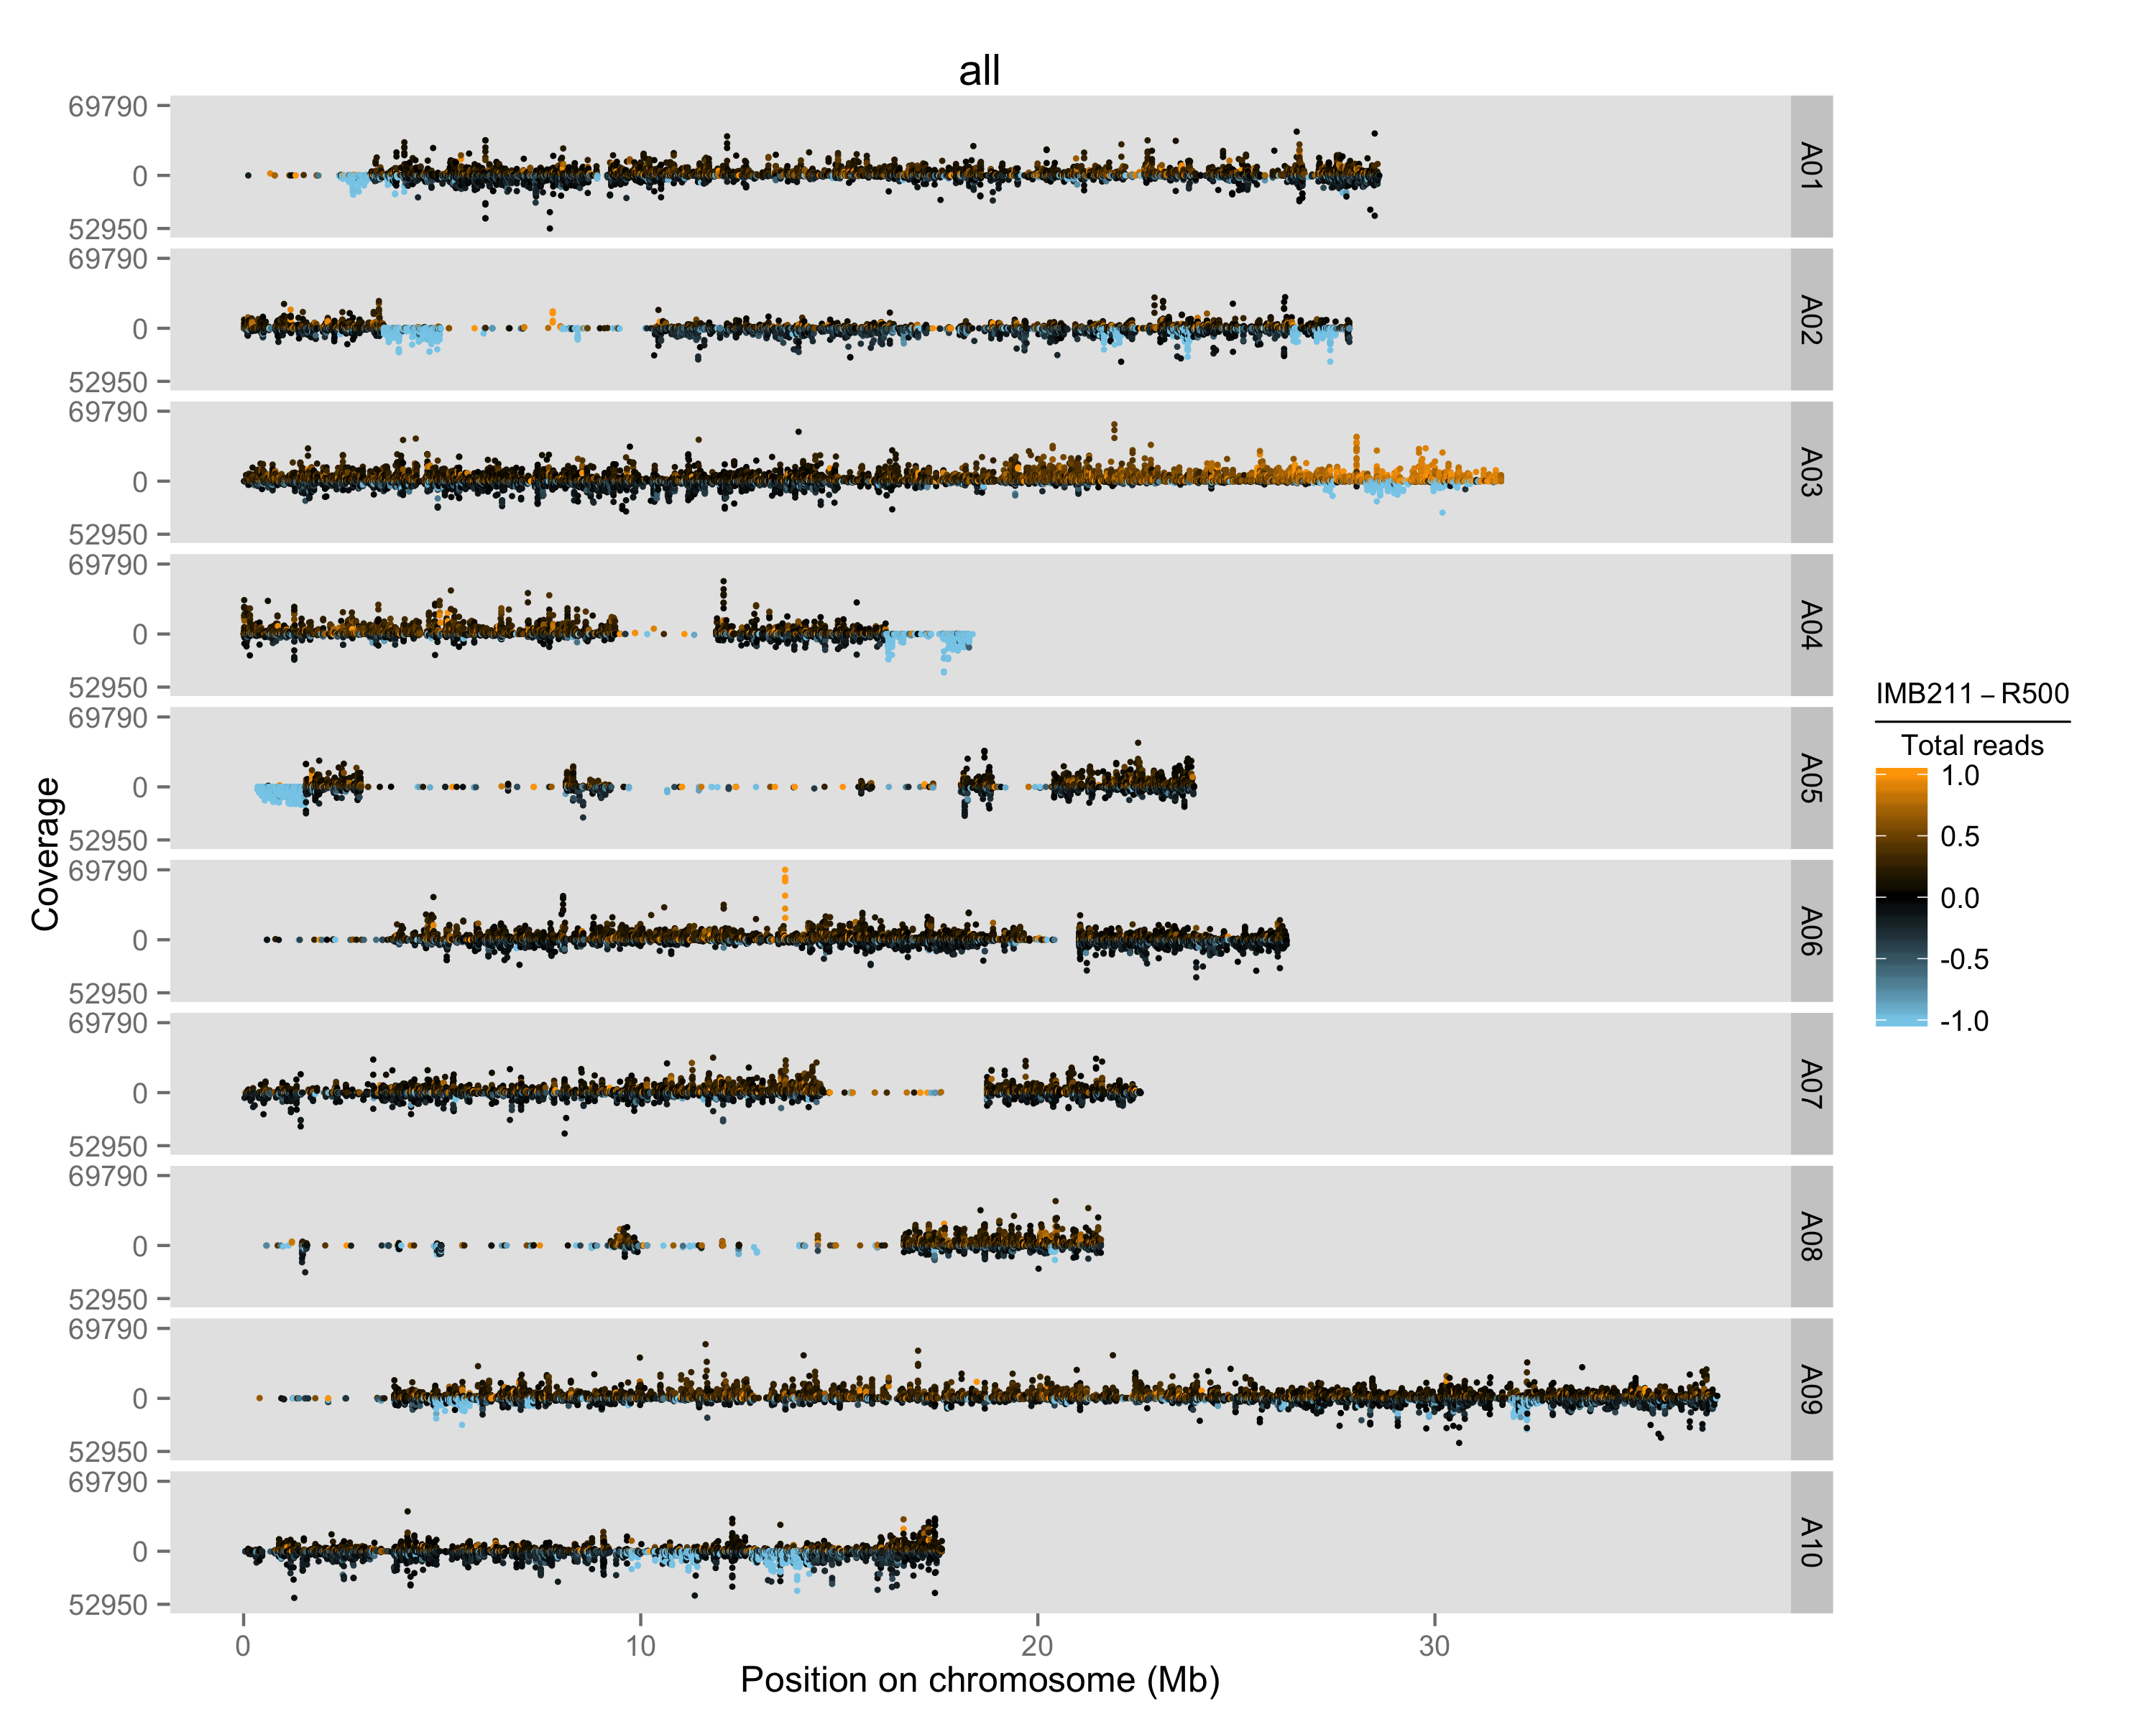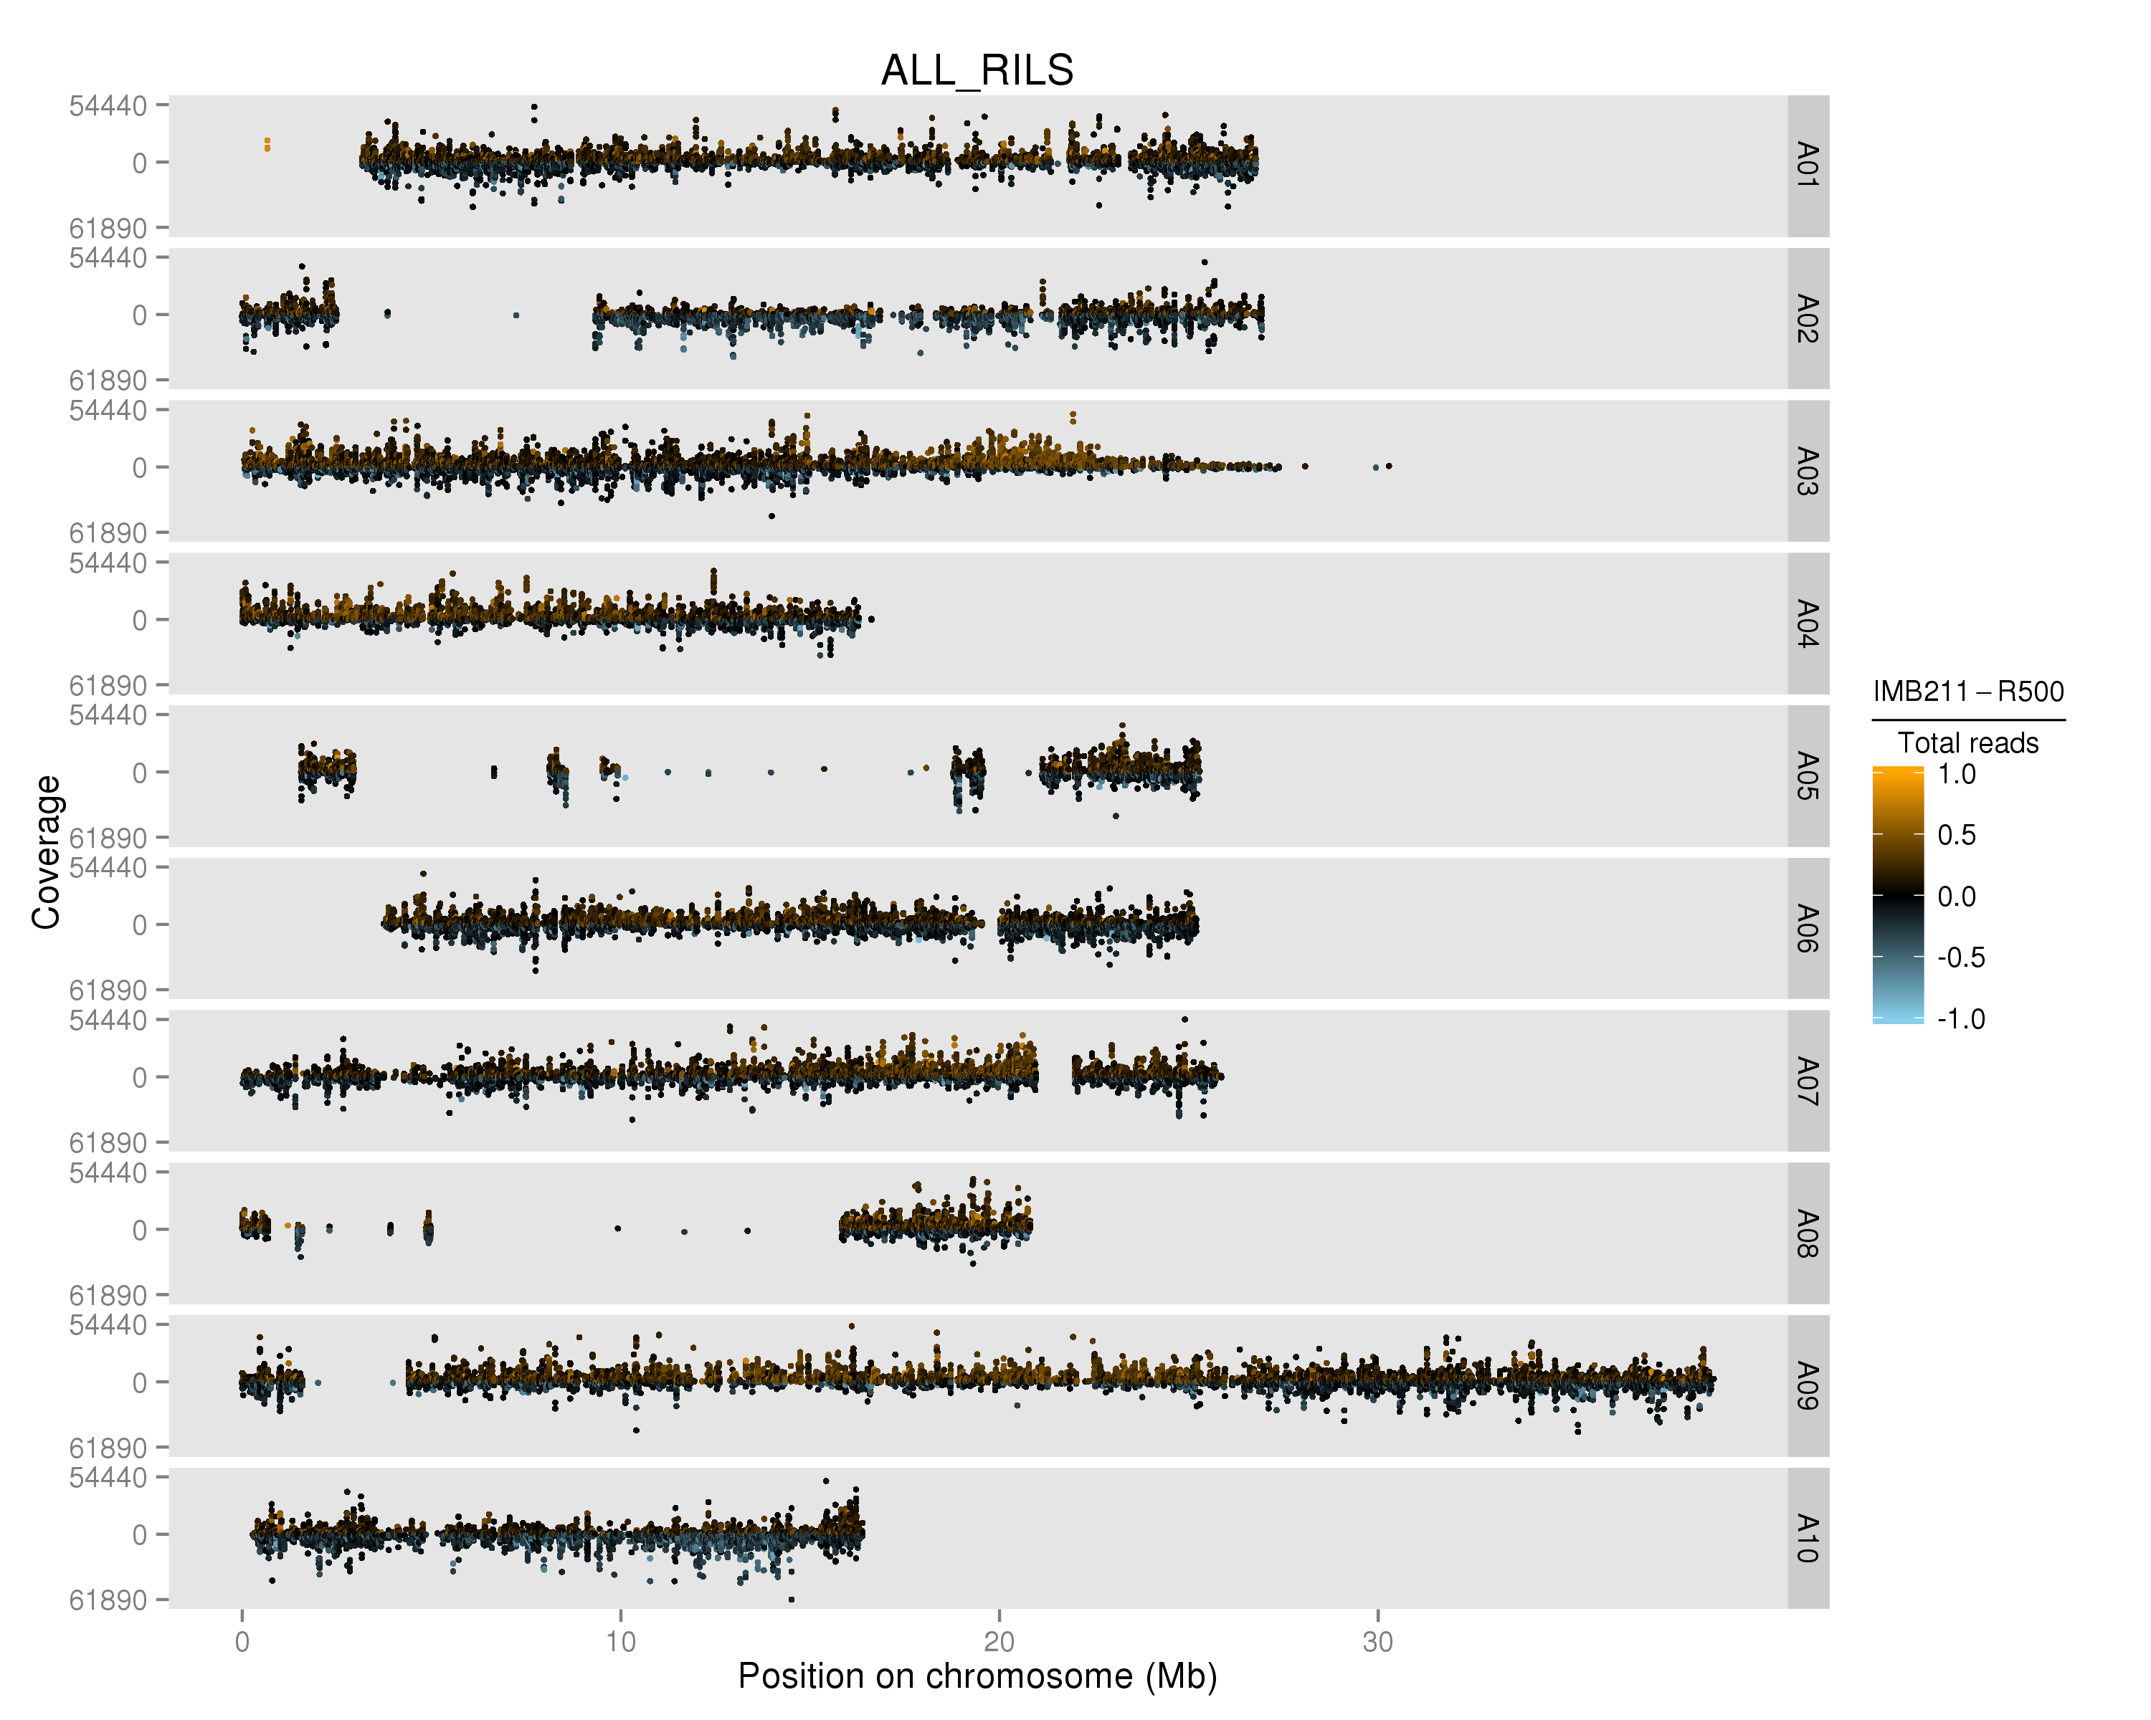

Figure 1. Plot of merged data from all RILs genotyped using the parent-based SNP set (left) and the population based SNP set (right). Each of the B. rapa ten chromosomes are displayed (A01-A10) with counts coverage of each SNP at each physical position on the chromosome in megabases (Mb). The color indicates the relative ratio of coverage between R500 and IMB211 for every SNP. Black is equal coverage, orange is more IMB211 and blue is more R500.

Table 1. SNP counts at different steps of the SNP discovery pipeline. The percentage of SNPs located on chromosomes or scaffolds remaining after each step are shown in parentheses. The first percentage is relative to the initial set of SNPs and the second percentage is relative to the set of SNPs from the previous step.

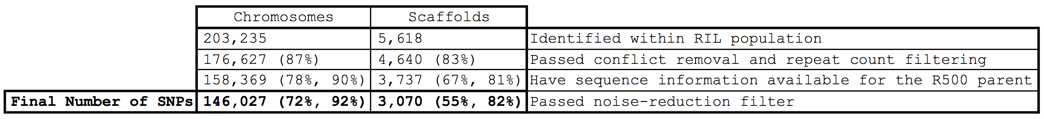

Table 2. Incorporated scaffolds represent a disproportionately high amount of scaffold sequence. Percentages of scaffold subset counts and total lengths relative to the set of all scaffolds are shown in parentheses.

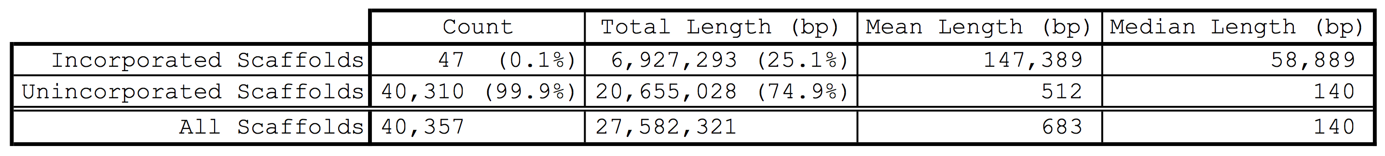

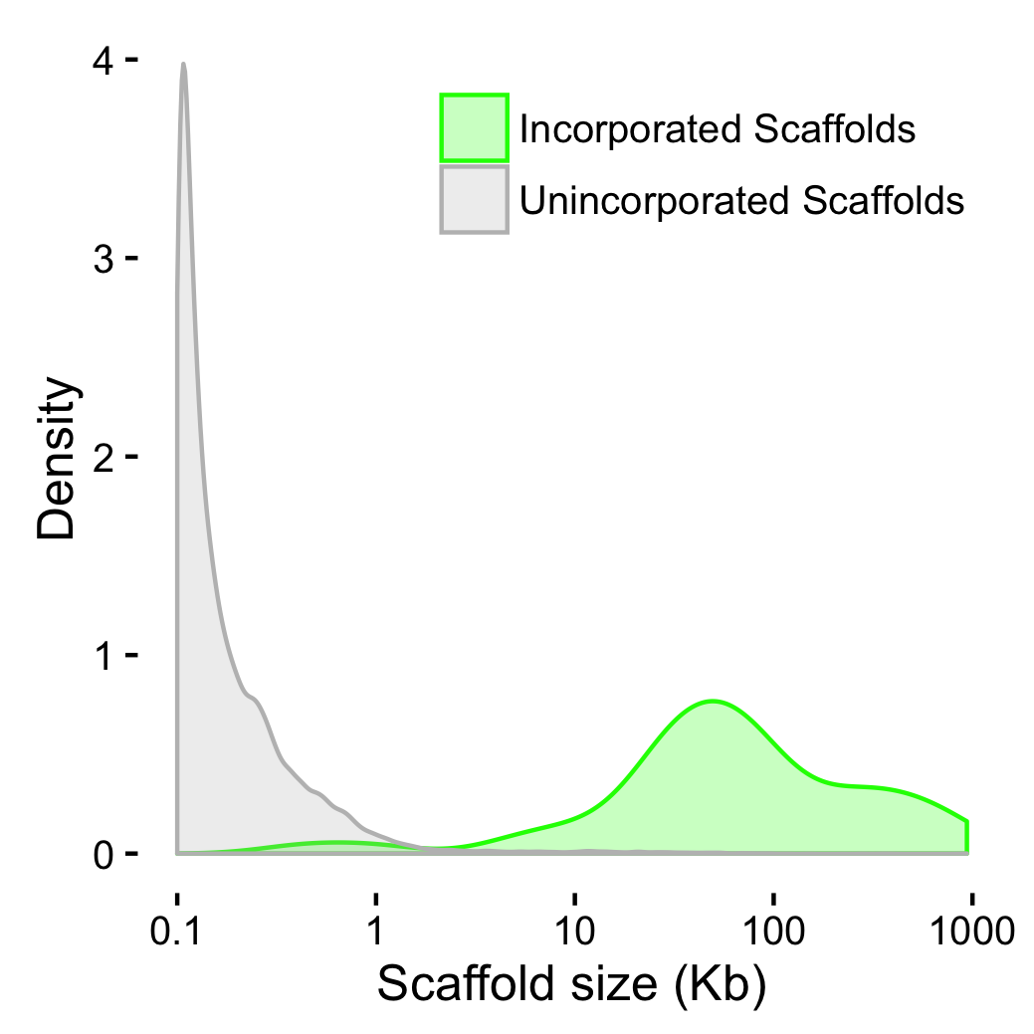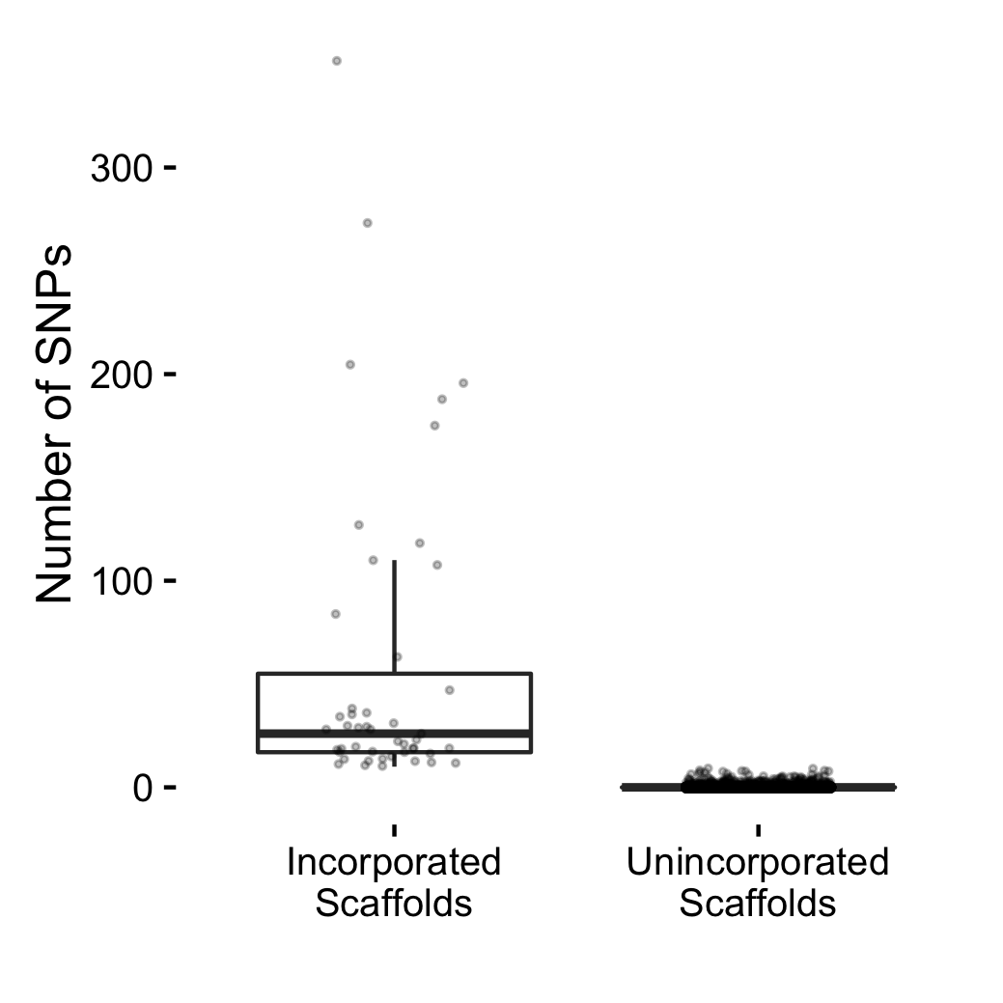

Figure 3. (A) Number of SNPs per scaffold. (B) Density distributions of scaffold sizes. Newly incorporated scaffolds are shown in green and unincorporated scaffolds are shown in gray.

composite-map.original.cluster-by-chr.pdf

Figure 4. Composite population genotype map with the position in physical distance across all ten chromosomes. Each RIL is represented as a single row displaying the genomic region inherited from IMB211 (Orange) or R500 (Blue). Small heterogeneous regions are represented in black.

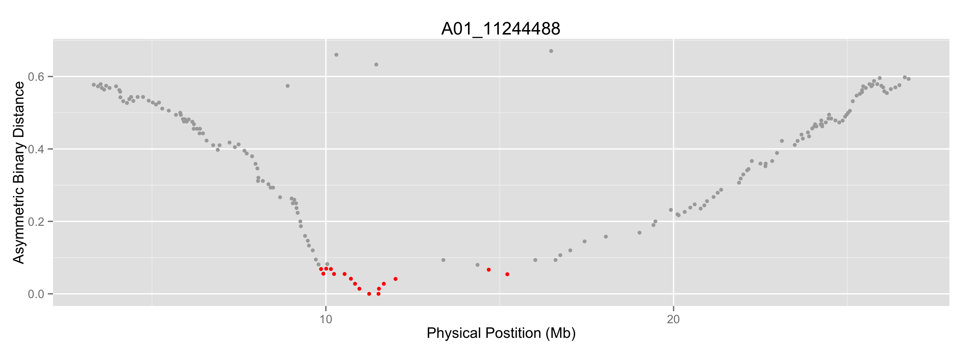

Figure 5. Representative asymmetric binary distance plot for a single molecular marker located on chromosome A01. Markers with 90% correlation are indicated in red. Potentially misplaced markers are circled in blue. Notice markers with physical positions based on version 1.5 of the genome are next to marker A01_11244488, but they have little correlation.

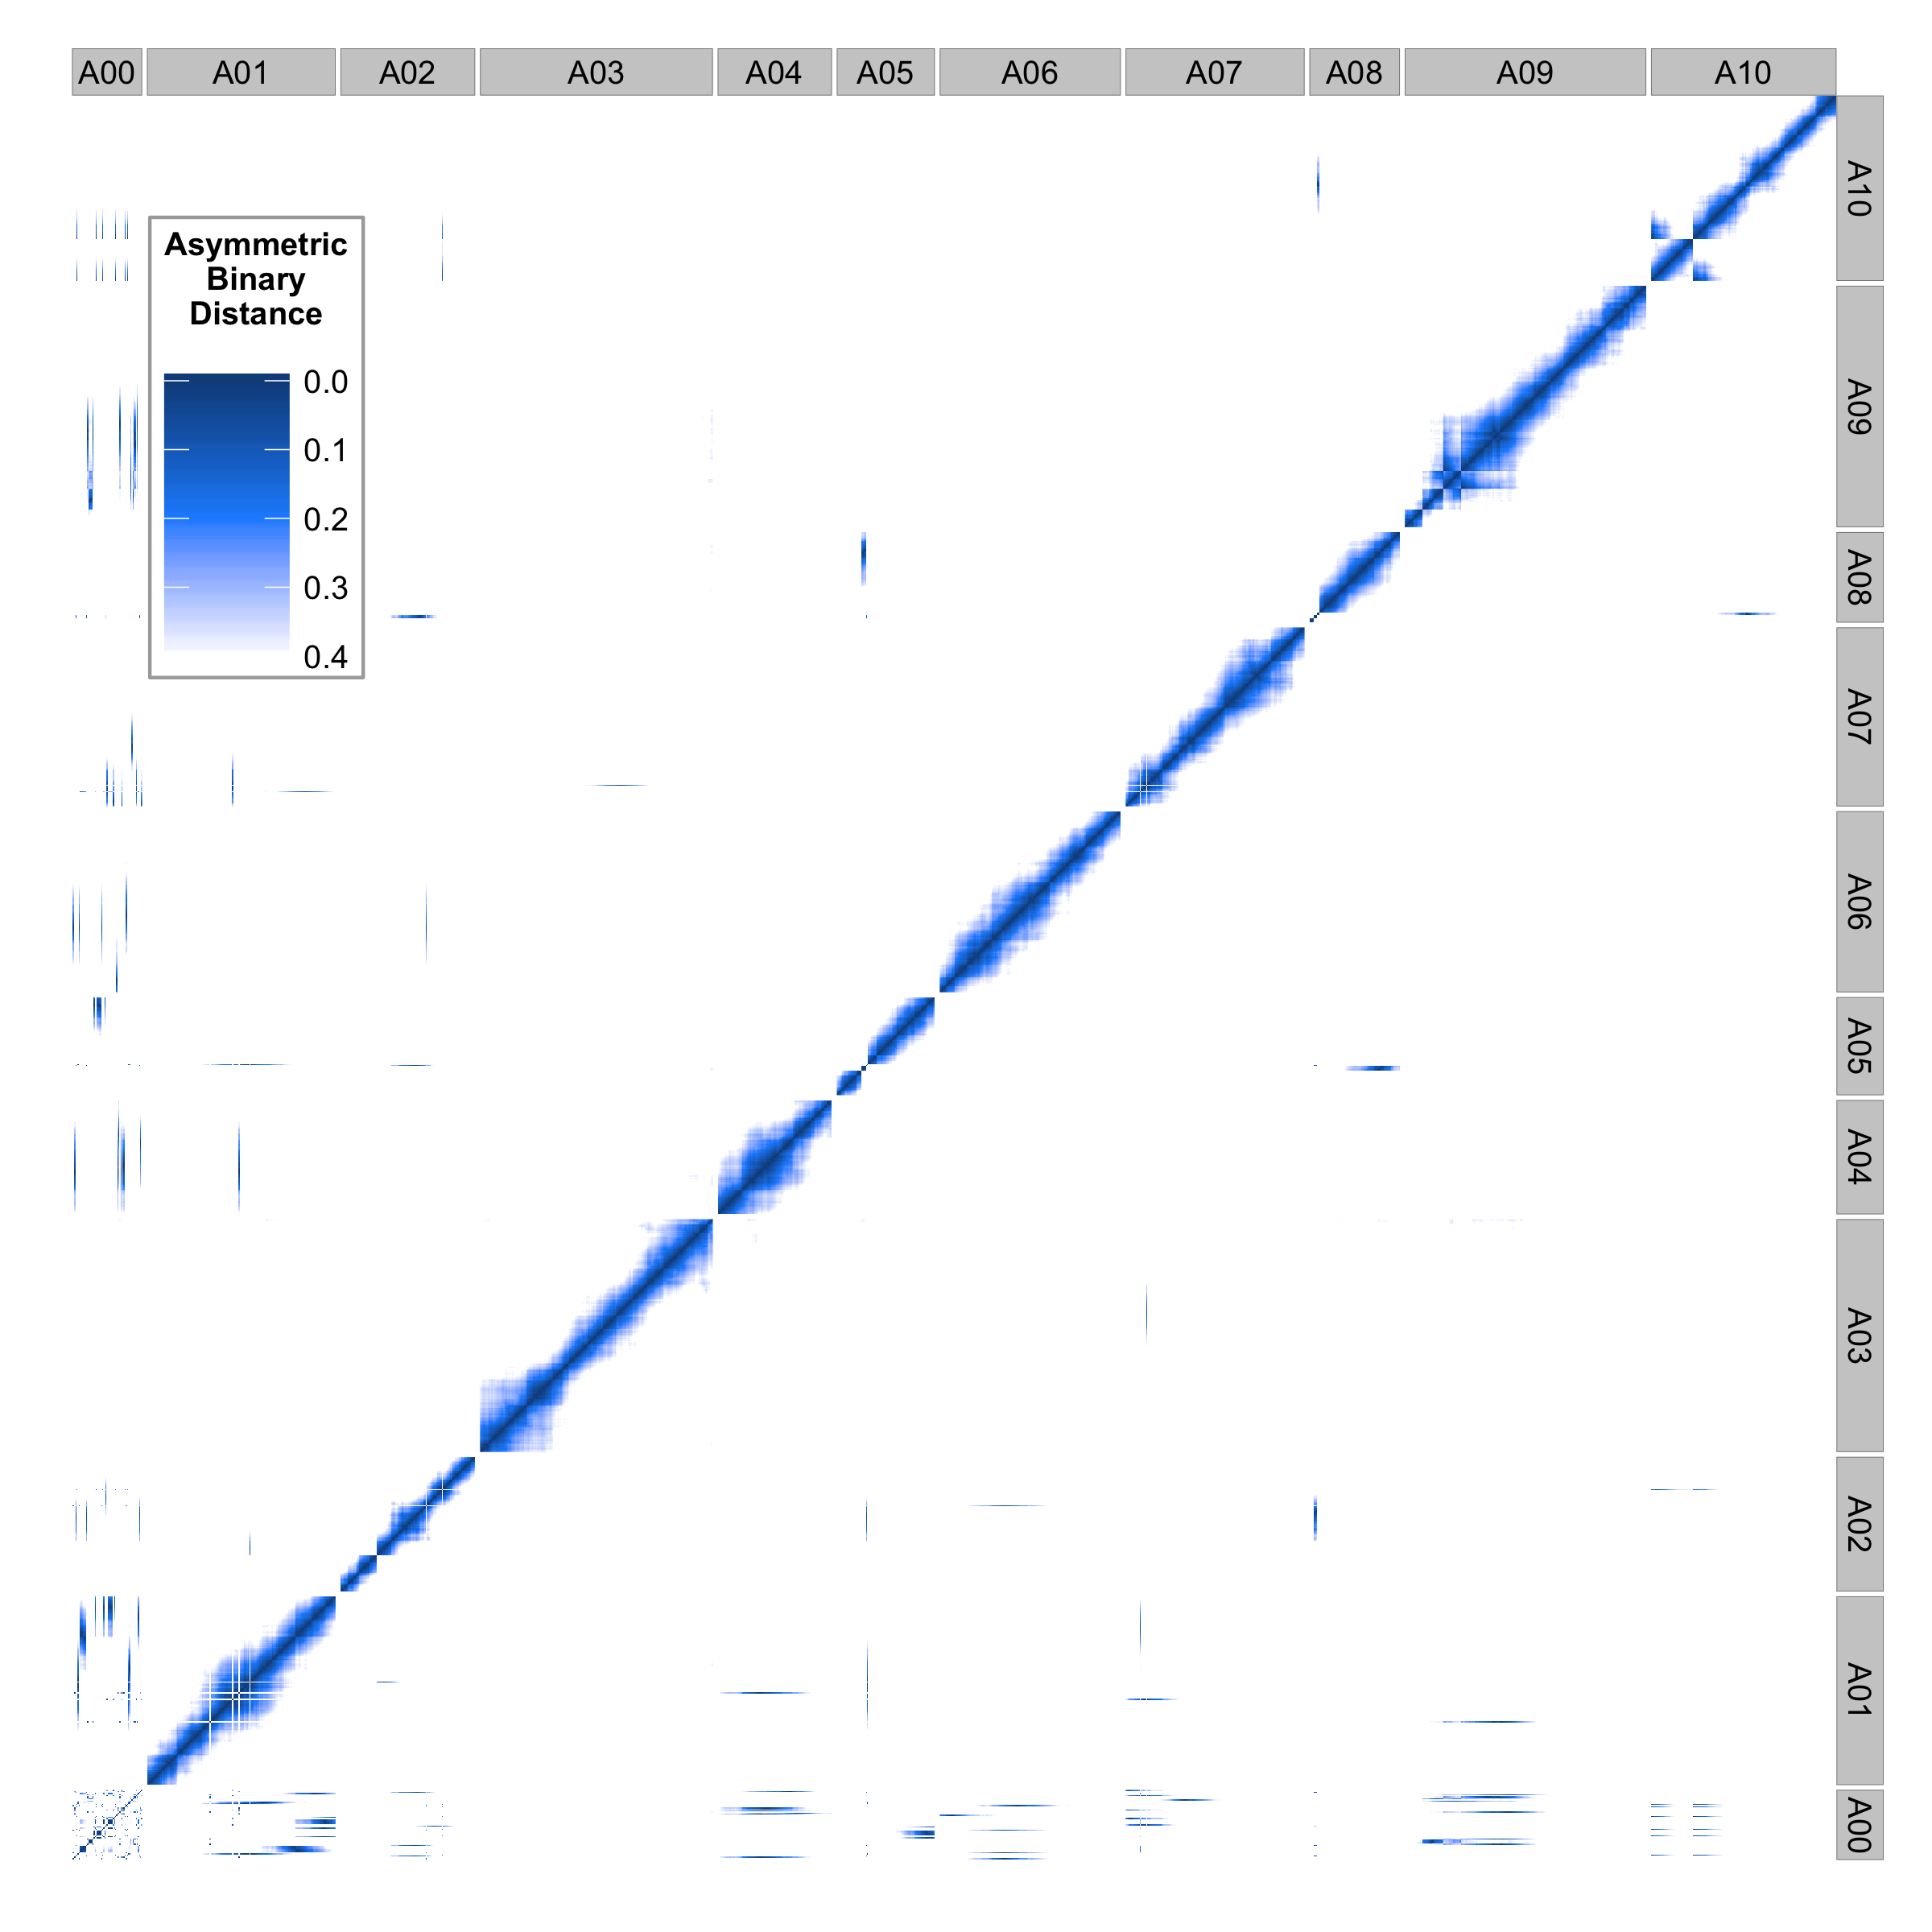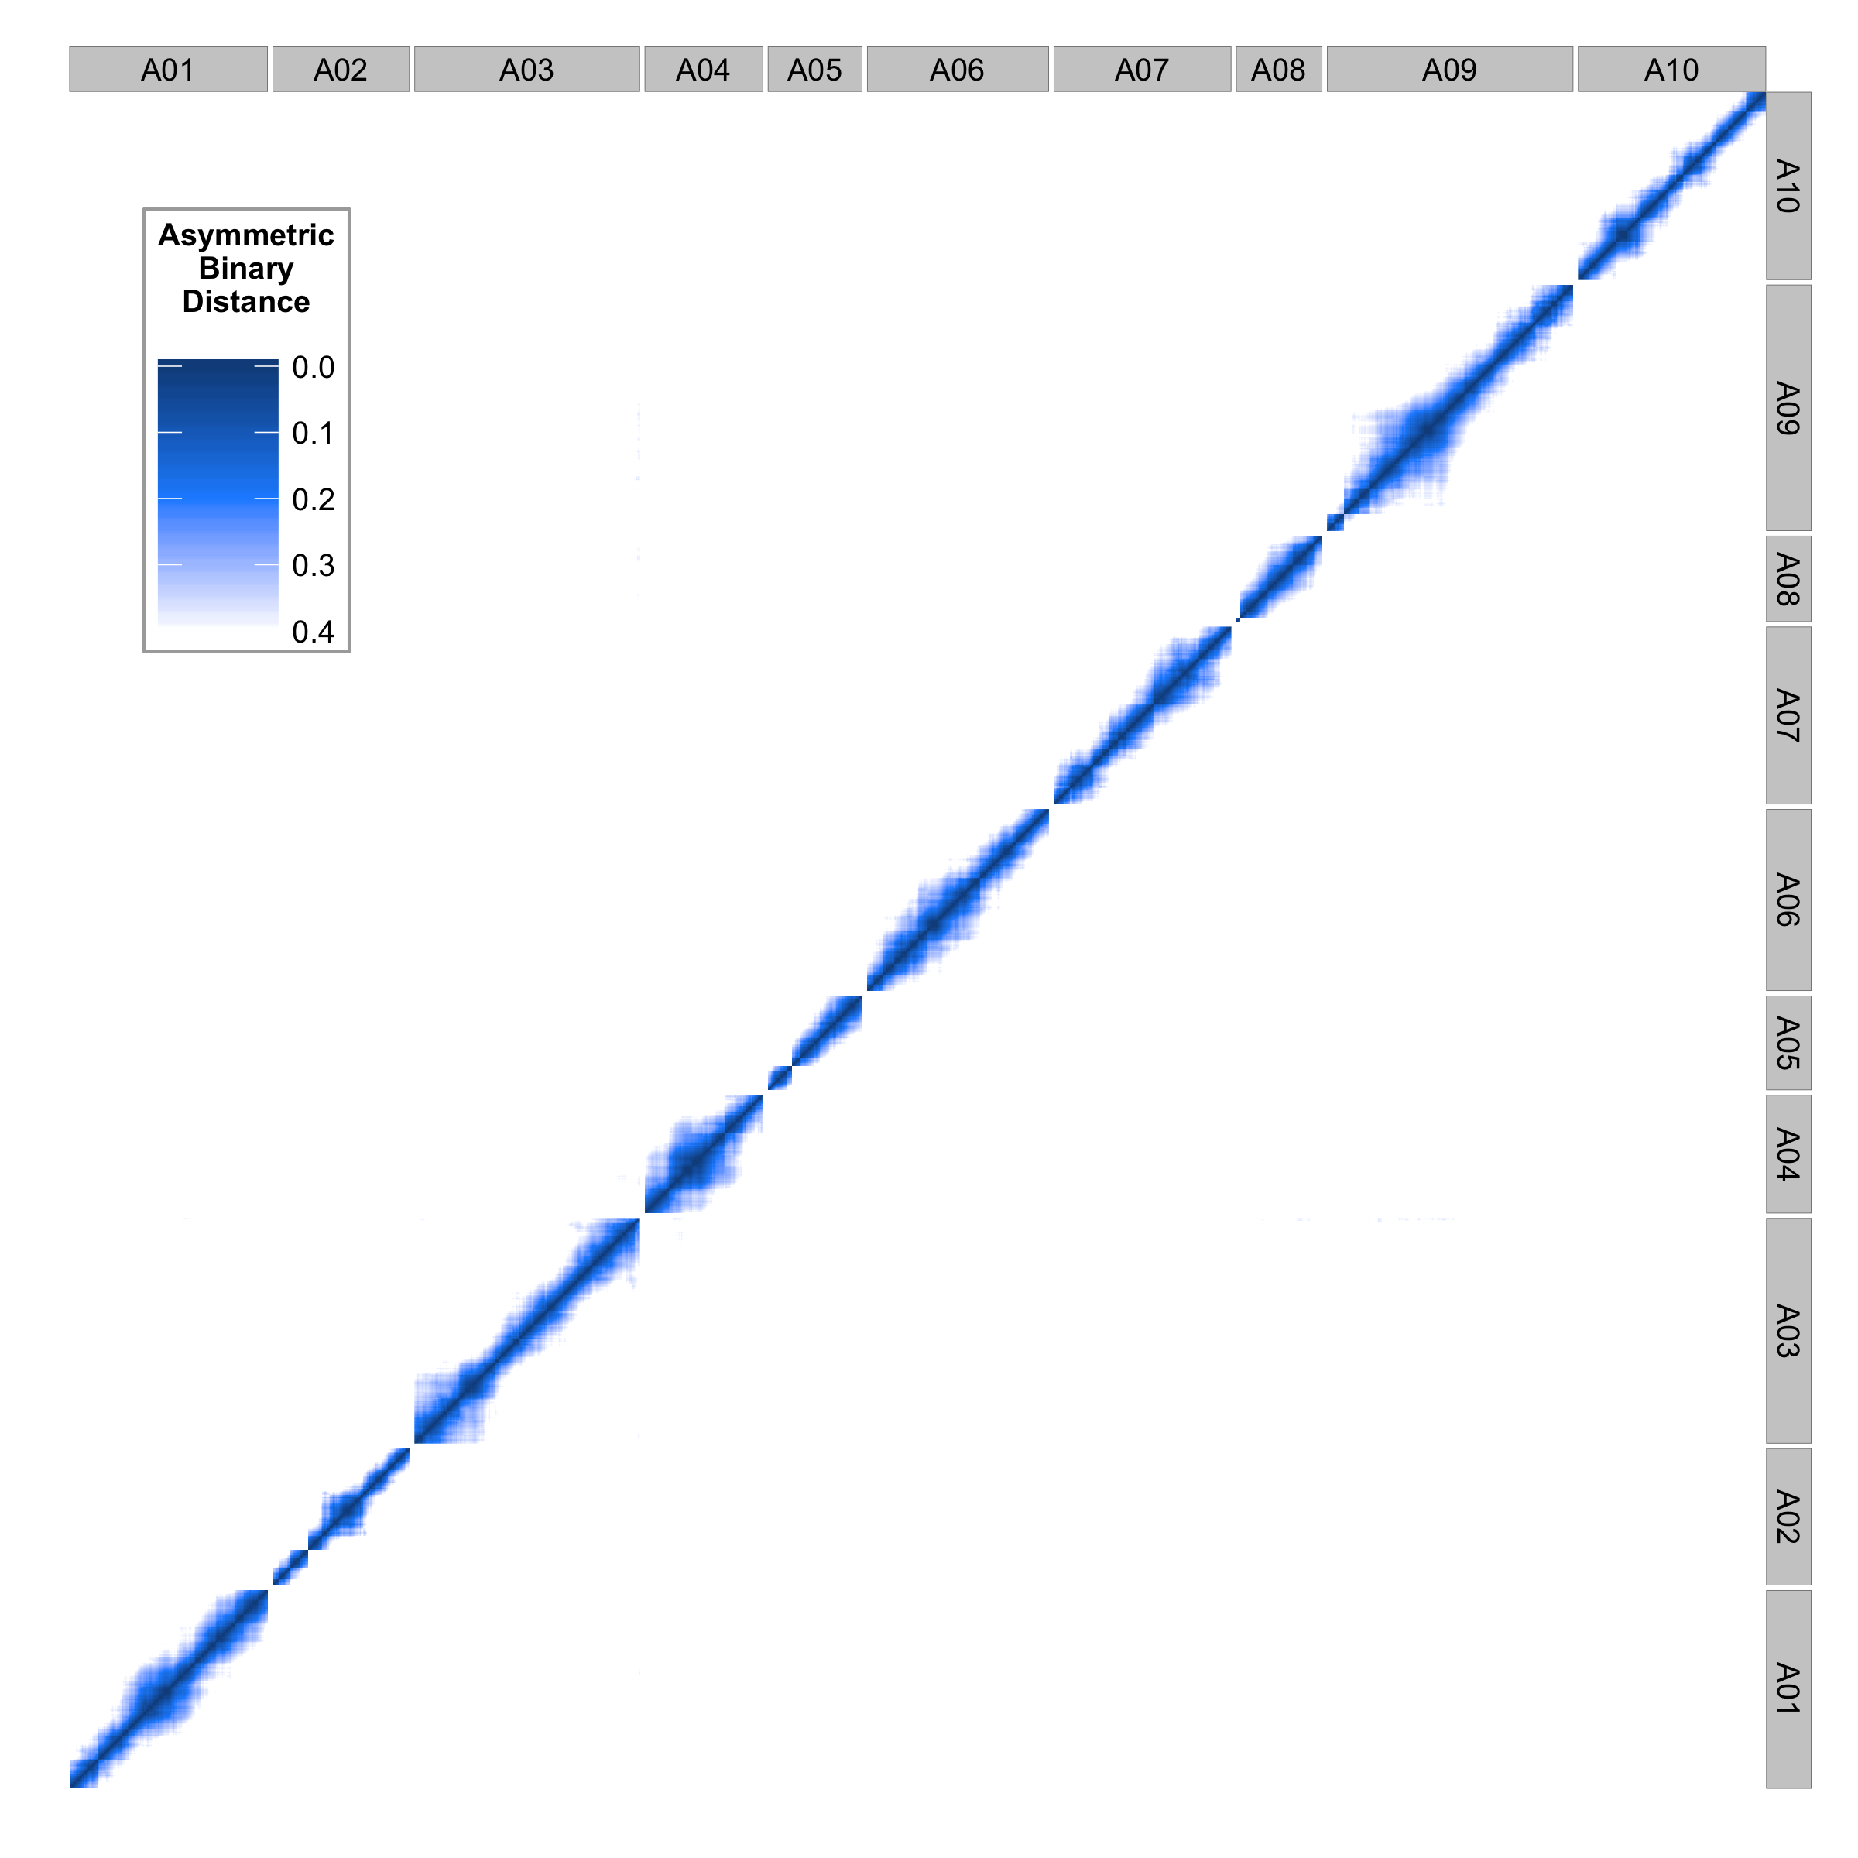

Figure 6. Genome wide asymmetric binary distance plots for each marker compared against every other marker based on chromosomal coordinates on *B. rapa* genome (A01-A10). A00 in the left plot represents the unplaced genomic scaffold sequences. Dark blue indicates high correlation (low asymmetric binary distance), while white indicates no correlation. The right plot is the final position of each marker and scaffold after applying our pipeline.



Figure 7. Physical position versus genetic position of each marker for chromosome A10 using genome version 1.5 (left) and fixed inversion using recombination information (right).



Figure 8. Physical position versus genetic position of each marker for chromosome A01 as an example. Genome version 1.5 (left) and accurately placed scaffolds using recombination information (right).

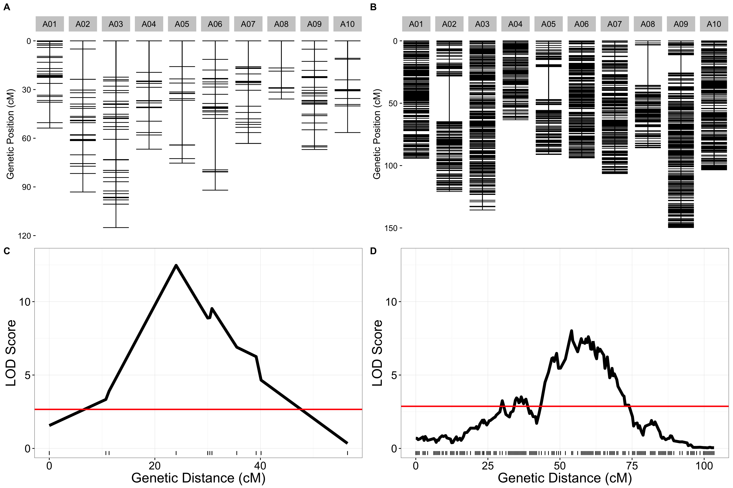

Figure 9. Old and new genetic map comparisons. Genetic markers for each chromosome are displayed in centimorgan distance (cM) for the old (A) and new (B) genetic maps. Comparison of likelihood odds scores for flowering time QTL using the old (C) and new (D) genetic maps.



Figure 10. A spline regression example for converting between physical and genetic distance on chromosome A01. These conversions can be used for sub setting genomic ranges for genes underlying significant QTL.

Bibliography

Baker, R. L., W. F. Leong, M. T. Brock, R. J. C. Markelz, M. F. Covington *et al.*, 2015 Modeling development and quantitative trait mapping reveal independent genetic modules for leaf size and shape. New Phytol. 208: 257–268.

Brock, M. T., J. M. Dechaine, F. L. Iniguez-Luy, J. N. Maloof, J. R. Stinchcombe *et al.*, 2010 Floral Genetic Architecture: An Examination of QTL Architecture Underlying Floral (Co)Variation Across Environments. Genetics 186: 1451–1465.

Broman, K. W., H. Wu, Ś. Sen, and G. A. Churchill, 2003 R/qtl: QTL mapping in experimental crosses. Bioinformatics 19: 889–890.

Chalhoub, B., F. Denoeud, S. Liu, I. A. P. Parkin, H. Tang *et al.*, 2014 Early allopolyploid evolution in the post-Neolithic Brassica napus oilseed genome. Science 345: 950–953.

Cheema, J., and J. Dicks, 2009 Computational approaches and software tools for genetic linkage map estimation in plants. Brief. Bioinform. 10: 595–608.

Cheng, F., T. Mandáková, J. Wu, Q. Xie, M. A. Lysak *et al.*, 2013 Deciphering the Diploid Ancestral Genome of the Mesohexaploid Brassica rapa. Plant Cell 25: 1541–1554.

Dechaine, J. M., M. T. Brock, and C. Weinig, 2014 QTL architecture of reproductive fitness characters in Brassica rapa. BMC Plant Biol. 14: 1.

Dechaine, J. M., J. A. Johnston, M. T. Brock, and C. Weinig, 2007 Constraints on the evolution of adaptive plasticity: costs of plasticity to density are expressed in segregating progenies. New Phytol. 176: 874–882.

Devisetty, U. K., M. F. Covington, A. V. Tat, S. Lekkala, and J. N. Maloof, 2014 Polymorphism Identification and Improved Genome Annotation of Brassica rapa Through Deep RNA Sequencing. G3 Genes Genomes Genet. 4: 2065–2078.

Fierst, J. L., 2015 Using linkage maps to correct and scaffold de novo genome assemblies: methods, challenges, and computational tools. Front. Genet. 6.:

Hahn, M. W., S. V. Zhang, and L. C. Moyle, 2014 Sequencing, Assembling, and Correcting Draft Using Recombinant Populations. G3 GenesGenomesGenetics 4: 669–679.

Iniguez-Luy, F. L., L. Lukens, M. W. Farnham, R. M. Amasino, and T. C. Osborn, 2009 Development of public immortal mapping populations, molecular markers and linkage maps for rapid cycling Brassica rapa and B. oleracea. Theor. Appl. Genet. 120: 31–43.

Kumar, S., T. W. Banks, S. Cloutier, S. Kumar, T. W. Banks *et al.*, 2012 SNP Discovery through Next-Generation Sequencing and Its Applications, SNP Discovery through Next-Generation Sequencing and Its Applications. Int. J. Plant Genomics Int. J. Plant Genomics 2012, 2012: e831460.

Liu, S., Y. Liu, X. Yang, C. Tong, D. Edwards *et al.*, 2014 The Brassica oleracea genome reveals the asymmetrical evolution of polyploid genomes. Nat. Commun. 5: 3930.

Lou, P., J. Wu, F. Cheng, L. G. Cressman, X. Wang *et al.*, 2012 Preferential Retention of Circadian Clock Genes during Diploidization following Whole Genome Triplication in Brassica rapa. Plant Cell 24: 2415–2426.

Lou, P., Q. Xie, X. Xu, C. E. Edwards, M. T. Brock *et al.*, 2011 Genetic architecture of the circadian clock and flowering time in Brassica rapa. Theor. Appl. Genet. 123: 397–409.

mfcovington/detect-boundaries GitHub.

mfcovington/SNPtools GitHub.

rjcmarkelz/brassica_genetic_map_paper GitHub.

Wang, X., H. Wang, J. Wang, R. Sun, J. Wu *et al.*, 2011 The genome of the mesopolyploid crop species Brassica rapa. Nat. Genet. 43: 1035–1039.

Xiao, D., J. J. Zhao, X. L. Hou, R. K. Basnet, D. P. D. Carpio *et al.*, 2013 The Brassica rapa FLC homologue FLC2 is a key regulator of flowering time, identified through transcriptional co-expression networks. J. Exp. Bot. 64: 4503–4516.